

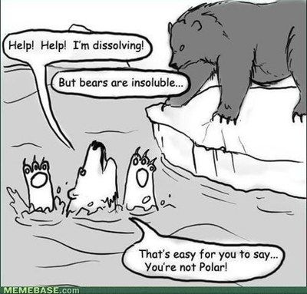Aqueous Solutions and Acidity

(Love-Lei n.d.)

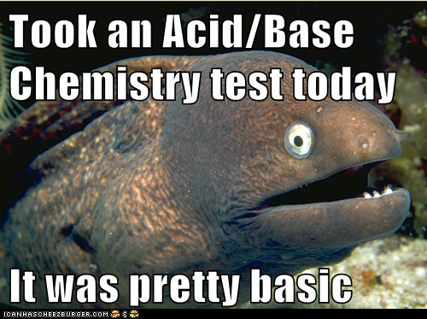 (Starr n.d.) (Acid Base Chemistry Jokes n.d.)

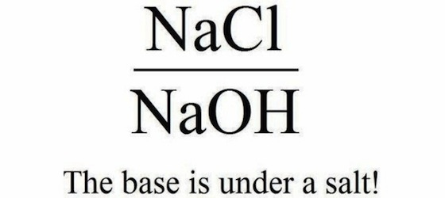

(Acid & Base Humour n.d.)

|  |  |  |  |
| --- | --- | --- | --- |
| **Week** | **Outcomes** | **References** | **Tasks** |
|  | * the unique physical properties of water, including melting point, boiling point, density in solid and liquid phases and surface tension, can be explained by its molecular shape and hydrogen bonding between molecules * the solubility of substances in water, including ionic and polar and non-polar molecular substances, can be explained by the intermolecular forces, including ion-dipole interactions between species in the substances and water molecules, and is affected by changes in temperature | Lucarelli p130 Set 25 (p131) q11,14-17  Lucarelli p137 Set 26 (p137) q7-8 |  |
|  | * solutions can be classified as saturated, unsaturated or supersaturated; the concentration of a solution is defined as the quantity of solute dissolved in a quantity of solution; this can be represented in a variety of ways, including by the number of moles of the solute per litre of solution (mol L-1) and the mass of the solute per litre of solution (g L-1) or parts per million (ppm) * the mole concept can be used to calculate the mass of solute, and solution concentrations and volumes involved in a chemical reaction | Lucarelli p135 Set 26 (p137) q1-6  Lucarelli p142 Set 28 (p146) q1-11, 16  Lucarelli p139 Set 27 (p140) q1-10 |  |
|  | * Complete from week 30 * the presence of specific ions in solutions can be identified by observing the colour of the solution, flame tests and observing various chemical reactions, including precipitation and acid-base reactions | Lucarelli p153 Set 30 (p155) q2,4,7  Lucarelli p149 Set 29  (p150) q1-7 | STAWA Experiment #22 p55 |
|  | * the Arrhenius model can be used to explain the behaviour of strong and weak acids and bases in aqueous solutions * patterns of the reactions of acids and bases, including reactions of acids with bases, metals and carbonates and the reactions of bases with acids and ammonium salts, allow products and observations to be predicted from reactants; ionic equations represent the reacting species and products in these reactions | Lucarelli p153 Set 30  (p155) q1,3,5-6,8-10  Lucarelli p157 Set 31  (p158) q1-10 |  |
|  | * indicator colour and the pH scale are used to classify aqueous solutions as acidic, basic or neutral * pH is used as a measure of the acidity of solutions and is dependent on the concentration of hydrogen ions in the solution * the mole concept can be used to calculate the mass of solute, and solution concentrations and volumes involved in a chemical reaction |  | Task 14:  Test-  Aqueous solutions and acidity |
|  | * Exam Preparation |  |  |
|  | * End of Year Exams |  |  |

Resources

Davis, A. *Nelson Chemistry Units 1 & 2.* South Melbourne: Cengage Learning Australia Pty Limited, 2014.

Lucarelli, N. *ESSENTIAL CHEMISTRY Australian Curriculum for WA ATAR Chemistry Units 1 + 2.* Willetton: Lucas Publications, 2014

Clark, J and Baddock, M *Exploring Chemistry Year 11 Experiments, Investigations and Problems* Osborne Park STAWA, 2014.

### In addition the following objectives will need to be mastered in order to pass this course.

### Science Inquiry Skills

* identify, research, construct and refine questions for investigation; propose hypotheses; and predict possible outcomes
* design investigations, including the procedure(s) to be followed, the materials required, and the type and amount of primary and/or secondary data to be collected; conduct risk assessments; and consider research ethics
* conduct investigations safely, competently and methodically for the collection of valid and reliable data, including: chromatography, measuring pH, rate of reaction, identification of the products of reactions, and determination of solubilities of ionic compounds to recognise patterns in solubility
* represent data in meaningful and useful ways, including using appropriate graphic representations and correct units and symbols; organise and process data to identify trends, patterns and relationships; identify sources of random and systematic error; identify anomalous data; estimate the effect of error on measured results; and select, synthesise and use evidence to make and justify conclusions
* interpret a range of scientific and media texts, and evaluate processes, claims and conclusions by considering the quality of available evidence; and use reasoning to construct scientific arguments
* communicate to specific audiences and for specific purposes using appropriate language, nomenclature and formats, including scientific reports

Unique Properties of Water

High melting and boiling points (0 °C and 100 °C respectively)

**This is** **due to water being able to form strong hydrogen bonds between molecules and increased by the fact that each water molecule can form up to four hydrogen bonds with other water molecules.**

The density of water increases with decreasing temperature until it is close to 0 °C after which its density starts to decrease and as it freezes, the density of the solid water becomes less than the density of the liquid water. For this reason, solid water (ice) floats in liquid water.

**This is due to the fact that when solid, the water molecules arrange themselves such that each water molecule is attracted to four other water molecules in a tetrahedral arrangement. This spatial arrangement causes the water molecules to be further apart in ice than in water.**

|  |  |
| --- | --- |
| **Temp** ( °C ) | **Density** pure water( g/cm3 ) |
| 0 (solid) | 0.9150 |
| 0 (liquid) | 0.9999 |
| 4 | 1.0000 |
| 20 | 0.9982 |
| 40 | 0.9922 |
| 60 | 0.9832 |
| 80 | 0.9718 |
| 100 (gas) | 0.000 |

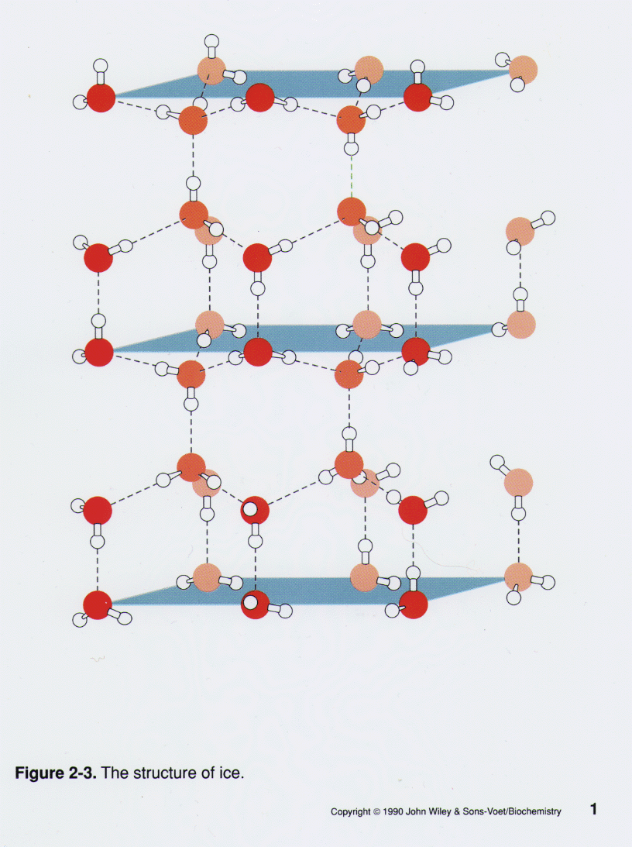

(Serianni 2015)

Water has high surface tension

**Surface tension is a liquids tendency to reduce its surface area. It is high in water due to the strong intermolecular forces at the surface of the liquid being unbalanced, causing the molecules to be pulled inwards.**

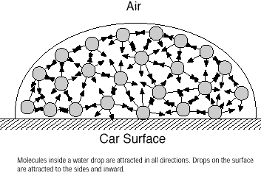

(Leon n.d.)

Solubility

**A solute is soluble in a solvent if the strength of the interactions between the solute and solvent molecules is strong enough to overcome the solvent-solvent interactions and the solute-solute interactions i.e. the energy produced from the formation of the solvent-solute interactions must be greater than the energy required to overcome the solute-solute and solvent-solvent interactions.**

**(The solute-solvent intermolecular forces are of similar strength to the solute-solute intermolecular forces and the solvent-solvent intermolecular forces.)**

Water is often referred to as the universal solvent because of the large range of substances (solutes) that are soluble in water.

The reasons for the solubility of various substances in water are:

* **Polar substances – depending on the nature of the polar substance, its solubility in water may be due to favourable hydrogen bonding interactions between the water and polar substance (e.g. methanol in water) or dipole-dipole interactions between the water and polar substance (e.g. propanone in water).**

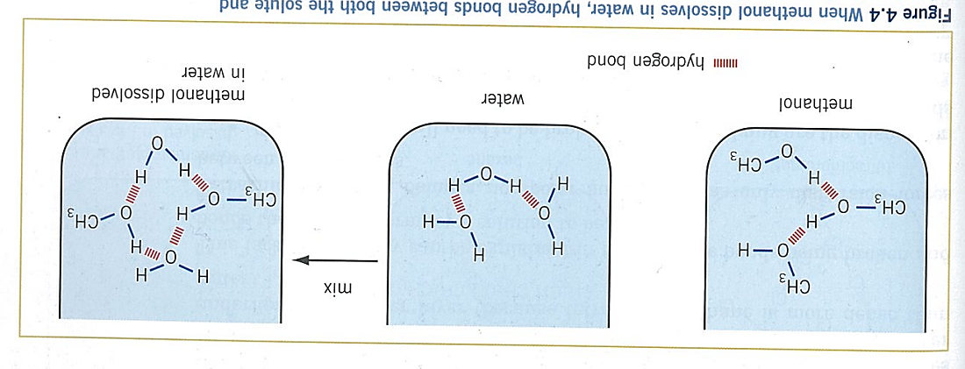

(Cherie Lewis 2012)

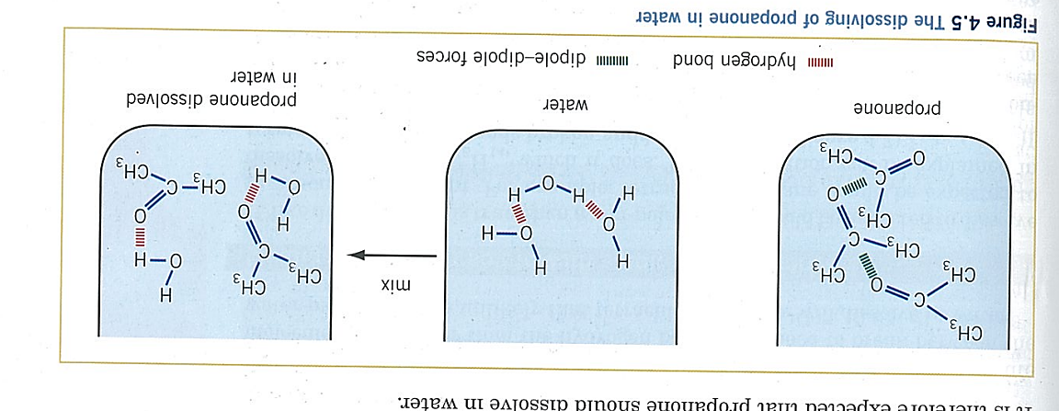

(Cherie Lewis 2012)

Not all polar substances are soluble in water. For example, when looking at the solubility of primary alcohols, it can be seen that as the carbon chain gets longer, the solubility of the alcohol in water becomes less. This is due to the dispersion forces becoming more and more significant which then interferes with the hydrogen bonding set up between the water and alcohol.

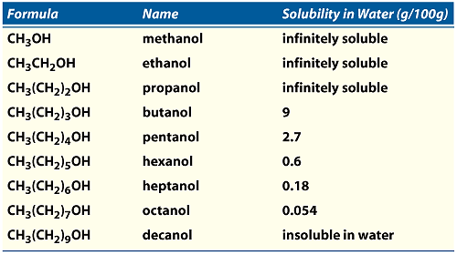

(Rochelle Schwartz-Bloom n.d.)

**It must be mentioned, however, that in terms of melting and boiling points, increasing dispersion forces add to the total strength of the intermolecular forces and increase melting and boiling points.**

**Substance: methanol CH3OH pentanol CH3CH2CH2CH2CH2OH**

Solubility (in water): more less

Boiling point: lower higher

* Ionic substances **– many ionic substances are soluble in water due to electrostatic forces of attraction set up between the ions and water molecules called ion-dipole forces. In this type of force positive ions are attracted to the negative end of the water dipole and negative ions are attracted to the positive end of the water dipole.**

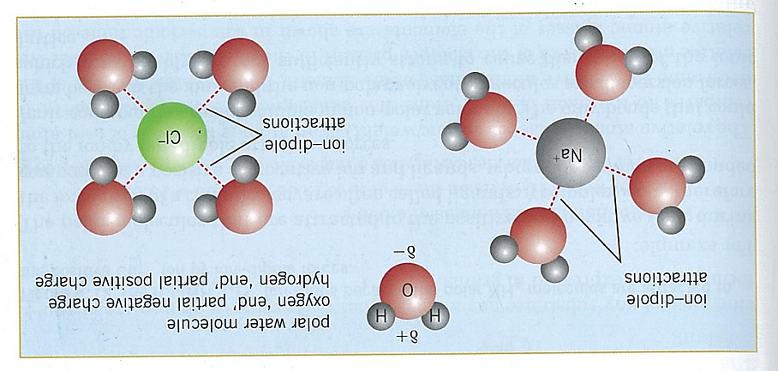

(Cherie Lewis 2012)

* Non-polar **substances – non-polar substances tend not to be soluble in water as the strength of the interactions between the solute and solvent molecules is not strong enough to overcome the solvent-solvent interactions and the solute-solute interactions (the energy produced in forming solvent-solute interactions is not strong enough to overcome the solute-solute interactions and solvent-solvent interactions).**

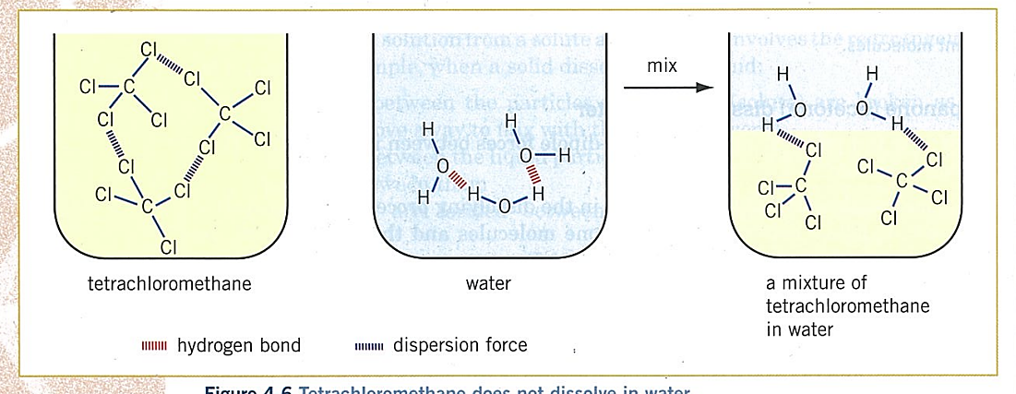

(Cherie Lewis 2012)

In general, as the temperature increases, **the solubility of solids and liquids increases in water but the solubility of gases tends to decrease.**

Solutions and Concentration

A solution is defined as a homogeneous mixture where the solute is dissolved uniformly throughout the solvent. Dissolved solutes that produce ions are often called electrolytes.

A solution can be unsaturated, saturated or supersaturated.

* Unsaturated – **a solution in which more solute can still be dissolved under the same conditions of temperature and pressure.**
* Saturated – a solution in which no more solute can be dissolved under the same conditions of temperature and pressure.
* Supersaturated – **a solution that contains more solute than a saturated solution could normally hold under the existing conditions of temperature and pressure. For example, if a saturated solution of sugar is heated more sugar will dissolve and may stay dissolved on returning to room temperature. Many supersaturated solutions are unstable and the presence of dust or the addition of a small quantity of solid solute can cause the excess solute to crystallize (“bomb”) out from the solution.**

**Concentration**

**The quantity of solute dissolved in a quantity of solvent is called the concentration**.

Concentration can be calculated in a number of ways, three of which are shown on the next page.

**Unless otherwise stated, it is assumed the volume of a solution is not changed by adding a solute.**

* **Moles per litre (mol L-1)** –

This is the number of moles of solute per litre of solution. It is calculated using the formula

concentration =  or c = 

Examples – calculate the concentration of:

1. a solution produced by dissolving 356 mol of sodium chloride in water to produce a 2.45 L solution. 145 mol L-1
2. a solution produced by dissolving 5.984×103 g of CaSO3 solid in water to produce a 8.974×104 L solution. 5.550 x 10-4 mol L-1
3. each ion present in a solution made by dissolving 2.03×102 g of Na3PO4 in water to produce a 182 mL solution.

C(Na+) = 20.4 mol L-1

C(PO43-) = 6.80 mol L-1

1. What mass of rubidium hydrogensulfate is needed to make up 500.0 mL solution with a concentration of 1.569 mol L-1? 143.2 g

* **Grams per litre (g L-1) –**

This is the mass of solute (in grams) per litre of solution. It is calculated using the formula:

concentration (g L-1) =  or c (g L-1) = 

Examples – calculate the concentration of:

1. a 98.3 L solution produced by dissolving 52 g of sodium chloride in water.

0.53 g L-1

1. a solution produced by dissolving 6.08×103 mol of Pb(MnO4)2 solid in 9.68×102 L of water.

2.80 x 103 g L-1

* **Parts per million (ppm) –**

This is the mass of solute in milligrams per kilogram of solution. It is calculated using the formula

concentration (ppm) =  or c (ppm) = 

Examples – calculate the concentration of:

1. a solution produced by dissolving 5.89×101 g of CrN to make a solution with a mass of 6.47×104g. 9.10x 102 ppm
2. a solution produced by dissolving 2.198×102 mol of iron (III) nitrite solid in 9.843×108 mL of water (assume water has a density of 1.000 g mL-1).

mFe(NO2)3 = 4.261 x 107 mg mH2O = 9.843x105 kg c = 4.329 x101 ppm

Precipitation Reactions

The solubility table can be used to determine whether or not an ionic compound will be soluble. If it is soluble, the process of it dissolving so the ions separate is called dissociation.

E.g. Dissociation equations

NaC*l*(s) → Na+(aq) + C*l*‒(aq)

Cr2(SO4)3(s) → 2Cr3+(aq) + 3SO42-(aq)

In the case of a molecular compound dissolving in water to produce ions, it is called ionisation.

E.g. Ionisation equations

HNO3(*l*) → H+(aq) + NO3‒(aq)

HCN(*s*) + H2O(*l*) ⇋ H3O+(aq) + CN‒(aq)  (note the use of the ⇋ arrow indicates that this ionisation only takes place to a limited extent)

If two solutions containing soluble solutes are mixed together and produce a solid, this is called a precipitation reaction. For example, suppose a sodium chloride solution is added to a silver nitrate solution. The reaction could be written as:

NaC*l*(aq) + AgNO3(aq) → AgC*l*(s) + NaNO3(aq)

the solubility table is used to determine the states of each substance in the reaction and as such if a precipitate is formed.

Observations for this reaction:

Two colourless solutions are added together to produce a white solid (note that **no compounds are named**, only generic descriptions).

OBSERVATIONS

When asked to write observations for chemical reactions the following apply:

* The colours of solutions are determined by the ions they contain. The colours of these ions in solution are given on the data sheet. Unless otherwise indicated, assume solid forms of the ions have the same colour as the ion in solution.
* If a solution has no colour, it is said to be colourless. Solids that formed from ions that have no colour will be white.
* Some ions have different colours depending upon the compound in which they are found. For example, CuSO4 solution is blue and so is CuSO4 solid, but CuCO3 solid is green and CuO solid is black.
* Common gases and their colours and odours include: H2 (colourless, odourless), CO2 (colourless, odourless), H2S (colourless, rotten egg odour), SO2 (colourless, pungent), NH3 (colourless, pungent), NO2 (brown, pungent), C­*l*2 (greenish-yellow, pungent)
* No reference must be made of the identity of the substance. Generic terms such as solid, solution, gas, etc. are to be used.

Examples – write balanced equations and give observations for the following precipitation reactions (note if no precipitate is formed, write ‘no observable change’).

1. Copper (II) nitrate solution is added to potassium sulfide solution.
2. Lead (II) acetate solution is added to a solution of calcium bromide.
3. Ammonium carbonate solution is added to sodium sulfate solution.
4. Cu(NO3)2(aq) + K2S(aq) → 2KNO3(aq) + CuS(s)

Blue solution is added to colourless solution. Blue solution becomes paler and black solid forms.

1. Pb(CH3COO)2(aq) + CaBr2(aq) → Ca(CH3COO)2(aq) + PbBr2s)

Two colourless solutions are added together. A white solid forms.

1. No observable change

Two colourless solutions are added together. There is no observable change.

g

When writing precipitation reactions (and other types of reactions) often some ions do not take part in the reaction. These are called **spectator ions**. If we remove the spectator ions, the chemical equation is referred to as an **ionic equation**. For example, in the previous reaction involving sodium chloride and silver nitrate solution when writing these two solutions, because they are soluble, we can write them in their dissociated form, i.e.

Na+(aq) + Cl‒(aq) + Ag+(aq) + NO3‒(aq)

with the products (solid silver chloride and sodium nitrate solution) we can write the solution in its dissociated form but not the solid (as this is insoluble).

AgCl(s) + Na+(aq) + NO3‒(aq)

Putting these two together, we can see that the sodium and nitrate ions appear the same on both sides of the arrow.

Na+(aq) + Cl‒(aq) + Ag+(aq) + NO3‒(aq) → AgCl(s) + Na+(aq) + NO3‒(aq)

As such, they are spectators and can be crossed out:

~~Na~~~~+~~~~(aq)~~ + Cl‒(aq) + Ag+(aq) + ~~NO~~~~3~~~~‒~~~~(aq)~~ → AgCl(s) + ~~Na~~~~+~~~~(aq)~~ + ~~NO~~~~3~~~~‒~~~~(aq)~~

Leaving behind the ionic equation which is written as:

Ag+(aq) + Cl‒(aq) → AgCl(s)

Notice that both the atoms and charges must balance.

**WRITING IONIC EQUATIONS:**

The following substances are written as separated ions

* Soluble ionic compounds in solution
* Solutions of strong acids (i.e. HC*l*, HNO3, H2SO4, HBr and HI)

The following substances are written as ‘normal’ formulae

* Insoluble ionic substances
* Covalent molecular or network substances in solid, liquid or gaseous states or in solution
* Weak acids (e.g. CH3COOH, H2CO3, H2SO3, H3PO4, H2C2O4, etc)
* Metals
* Solid ionic compounds

Examples – write balanced ionic equations for the following reactions (note if no precipitate is formed or change is observed, write ‘no observable change’).

1. Strontium (II) iodide solution is added to potassium sulfate solution.
2. Manganese (II) chloride solution is added to a solution of barium hydroxide.
3. Solid calcium carbonate is added to hydrochloric acid to produce calcium chloride solution, carbon dioxide gas and water.
4. Sr2+(aq) + SO42- (aq) → SrSO4(s)

Colourless solution added to colourless solution. White solid forms.

1. Mn2+(aq) + 2OH- (aq) → Mn(OH)2(s)

Pale pink solution is added to colourless solution. Pink solution becomes paler and pale pink solid forms.

1. CaCO3(s)  + 2H+(aq) →Ca2+(aq) + H2O(l) + CO2(g)

Colourless solution is added to white solid. White solid dissolves and bubbles of a colourless

odourless gas form.

**Distinguishing between unknown solutions**

Precipitation reactions can be used to distinguish between unknown solutions. In this type of question, specific solutions must be identified and the observations of the named unknown solutions must be given.

For example, distinguish between two unlabelled solutions of sodium sulfate and sodium hydroxide.

Possible answer:

Add magnesium nitrate solution to both. The sodium hydroxide solution will produce a white precipitate (solid) whilst there will be no observable change with the sodium sulfate solution.

Note that if a question asks, “Using a chemical test distinguish between…,” you must perform a chemical reaction of some sort (i.e. you cannot use simple solubility in water or the original colour of solutions to determine identities). If the question asks. “Using a test distinguish between…,” then solubility in water and the original colours of solutions are fine.

Examples – Use a chemical test to distinguish between the following substances.

1. Potassium hydroxide solution and potassium bromide.
2. Zinc bromide solution and zinc iodide solution.
3. Sodium sulfide solid and sodium phosphate solid.

Below is one particular option, but there is more than one option for each.

1. Add magnesium nitrate solution to both solutions. A white solid (precipitate) will form in the potassium hydroxide solution. There will be no observable change with the potassium bromide solution.
2. Add lead nitrate solution to both solutions. A bright yellow solid (precipitate) will form in the zinc iodide solution. A white solid will form with the zinc bromide solution.
3. Add water to both solids to make solutions. Then add copper nitrate solution to both the solutions. A black solid forms in the sodium sulphide solution. A blue solid forms in the sodium phosphate solution.

Acids and Bases

In general acids turn blue litmus (an indicator paper) red and taste sour. They conduct an electric current but it depends on the strength of the acid.

In general bases turn red litmus blue, taste bitter, will also conduct an electric current and can have a slippery, soapy feel.

**Arrhenius** theory of acids and bases was an early attempt at explaining the properties of acids and bases. He suggested:

Acids:

* contain H in their formula
* produce hydrogen ions in solution
* can be strong (i.e. fully ionise in solution e.g. HC*l*(g) → H+(aq) + C*l*‒(aq))
* can be weak (i.e partially ionise in solution e.g. CH3COOH(s) ⇋ H+(aq) + CH3COO‒(aq))

Bases:

* contain OH in their formula
* produce hydroxide ions in solution
* completely dissociate in solution (e.g. NaOH(s) → Na+(aq) + OH‒(aq))

Problems with the theory:

* Some bases produce OH− ions in solution yet do not have OH in their formula (eg NH3 ; Na2CO3 and Na2O).
* Restricted to aqueous solutions.
* Does not allow for the existence of hydronium ions (H3O+).

**Brønsted-Lowry Theory**

Acids are proton (H+) donors.

Strong acid: HCl(aq) + H2O(l) → H3O+(aq) + Cl−(aq)

HCl is donating a proton and acting as an acid. The H2O is accepting a proton and acting as a base.

Weak acid: CH3COOH(aq) + H2O(l)  H3O+(aq) + CH3COO−(aq)

CH3COOH(aq) is donating a proton and acting as an acid. The H2O is accepting a proton and acting as a base.

Bases are proton (H+) acceptors.

eg ammonia: NH3(aq) + H2O(l) NH4+(aq) + OH−(aq)

NH3(aq) is accepting a proton and acting as a base. The H2O is donating a proton and acting as an acid.

* The greater the tendency of the acid to donate a proton to water ie the stronger the acid is and the greater the degree of its ionisation. (Strong acids fully ionise in water.)
* Remember when writing **ionic equations** for acids:

Strong acids are written as separated ions

Weak acids are written as ‘normal’ formulae.

General acid and base reactions include:



1. acid + reactive metal → salt + hydrogen gas
2. acid + metal hydroxide (base) → salt + water
3. acid + metal oxide (base) → salt + water
4. acid + metal carbonate (base) → salt + carbon dioxide + water
5. acid + metal hydrogencarbonate (base) → salt + carbon dioxide + water
6. acid + metal sulfite → salt + sulfur dioxide + water
7. acid + ammonia → ammonium salt
8. base + ammonium salt → salt + ammonia + water



1. base + non-metal oxide → salt + water
2. water + group 1 metal → metal hydroxide + hydrogen gas
3. Acidic solutions dissolve most metals forming a salt and hydrogen gas. Au, Ag, Pt and Cu are unaffected by dilute acids.

**ACID + METAL → SALT + H2(g)**

(Eg: Some hydrochloric acid solution is poured onto a strip of nickel metal)

**2HCl(aq) + Ni(s) → NiCl2(aq) + H2(g)**

**2H+(aq) + Ni(s) → Ni2+(aq) + H2(g)**

1. **ACID + METAL HYDROXIDE → SALT + H2O**

(Eg: Calcium hydroxide solution is added to a solution of nitric acid)

**2HNO3(aq) + Ca(OH)2(aq) → Ca(NO3)2(aq) + 2H­2O(l)**

**H+(aq) + OH−(aq) → H2O(l)**

1. **ACID + METAL OXIDE → SALT + H2O**

(Eg: Some solid copper (II) oxide is added to a solution of carbonic)

**H2CO3(aq) + CuO(s) → CuCO3(aq) + H­2O(l)**

**H2CO3(aq) + CuO(s) → Cu2+(aq) + CO32- (aq) + H2O(l)**

1. **ACID + CARBONATE → SALT + H2O + CO2(g)**

(Eg: Hydrochloric acid solution is added to nickel carbonate solid)

**2HCl(aq) + NiCO3(s) → NiCl2(aq) + H2O(l) + CO2(g)**

**2H+(aq) + NiCO3(s) → Ni2+(aq) + H2O(l) + CO2(g)**

1. **ACID + HYDROGENCARBONATE → SALT + H2O + CO2(g)**

(Eg: Ethanoic acid solution is added to solid zinc hydrogencarbonate)

**2CH3COOH(aq) + Zn(HCO3)2(s) → Zn(CH3COO)2(aq) + 2H2O(l) +2CO2(g)**

**2CH3COOH(aq) + Zn(HCO3)2(s) → Zn2+(aq) + 2CH3COO-(aq) + 2H2O(l) +2CO2(g)**

1. **ACID + METAL SULFITE → SALT + H2O + SO2(g)**

(Eg: Hydrochloric acid solution and sodium sulphite powder are mixed)

**2HCl(aq) + Na2SO3(s) → 2NaCl(aq) + H2O(l) + SO2(g)**

**2H+(aq) + Na2SO3(s) → 2Na+ (aq) + H2O(l) + SO2(g)**

1. **ACID + AMMONIA → AMMONIUM SALT**

(Eg: Ammonia gas is bubbled into a hydrochloric acid solution)

**2HCl(aq) + NH3(g) → NH4Cl(aq)**

**H+(aq) + NH3(g) → NH4+(aq)**

1. **BASE + AMMONIUM SALT → SALT + H2O + NH3(g)**

(Eg: A potassium hydroxide solution is mixed with an ammonium chloride solution)

**KOH(aq) + NH4Cl(aq) → KCl(aq) + H2O(l) + NH3(g)**

**NH4+(aq) + OH-(aq) → H2O(l) + NH3(g)**

1. **BASE + NON-METAL OXIDE → SALT + H2O**

(Eg: Sulfur dioxide gas is bubbled through a potassium hydroxide solution)

**SO2(g) + 2KOH(aq) → K2SO3(aq) + H2O(l)**

**SO2(g) + 2OH-(aq) → SO32-(aq) + H2O(l)**

1. **WATER + GROUP 1 METAL → METAL HYDROXIDE + H2**

**2H2O(l) + 2Na(s) → 2NaOH(aq) + H2(g)**

**2H2O(l) + 2Na(s) → 2Na+ OH(aq) + H2(g)**

Indicators and the pH Scale

An indicator is a solution that changes colour depending on the pH of the solution it is added to. Universal indicator is a mixture of indicators that changes colour over the pH scale from 1-14.

|  |  |  |
| --- | --- | --- |
| pH Range | Description | Colour |
| <3 | strong acid | red |
| 3-6 | weak acid | orange/yellow |
| 7 | neutral | green |
| 8-11 | weak base | blue |
| >11 | strong base | violet/purple |

Universal indicator can be used to help determine whether a solution is acidic, basic or neutral.

* The pH scale is dependent on the concentration of hydrogen ions in solution.
* It is calculated using the formula pH = ‒log10[H+] (or [H3O+])
* The greater the concentration of hydrogen ions, the more acidic the solution (the lower the pH).
* The lower the concentration of hydrogen ions, the more basic the solution (the higher the pH).

For every pH unit that is increased, the concentration of hydrogen ions present decreases by a factor of 10. For example, a solution of pH 1 has a hydrogen ion concentration of 1.00×10-1 mol L-1 but a solution of pH 2 has a hydrogen ion concentration of 1.00×10-2 mol L-1.

A very small amount of water undergoes ionisation to produce hydrogen ions and hydroxide ions according to the equation:

H2O(*l*) ⇋ H+(aq) + OH‒(aq) (Arrhenius)

2H2O(*l*) ⇋ H3O+(aq) + OH‒(aq) (Bronsted-Lowry)

For every water molecule that ionises, an equal number of hydrogen ions and hydroxide ions are produced. These neutralise each other which means water is always neutral. It usually has a pH of 7 but even if the pH is above or below 7, at different temperatures, it is still neutral.

[H3O+] = [OH-] = neutral

[H3O+] > [OH-] = acidic

[H3O+] < [OH-] = basic

Stoichiometry and Solutions

Using the formula **n = cV**, calculations involving chemical reactions with solutions can be performed.

For example: Calculate the mass of tin (IV) hydroxide produced when 3.45×10-1 L of 1.982×101 mol L-1 tin (IV) nitrate reacts with excess sodium hydroxide solution.

nSn(NO3)4 = cV = (1.982 x 10)(3.45 x10-1) = 6.8379mol

Sn(NO3)4(aq) + 4NaOH(aq) → 4NaNO3(aq) + Sn(OH)4(s)

OR

Sn4+(aq) + 4OH-(aq) → Sn(OH)4(s)

nSn(OH)4 = nSn(NO3)4 = 6.8379 mol

mSn(OH)4  = nM = (6.8379)(186.732) = 1.28 x 103 g

Using **all the formulae** we have learnt throughout the year, it is now possible to perform stoichiometric calculations for chemical equations using solids, liquids, gases and solutions.

For example; calculate the volume of carbon dioxide gas produced at STP when 896 mL of

6.09×10-2 mol L-1 nitric acid reacts with 3.44 g of solid calcium carbonate.

2HNO3 + CaCO3 → Ca(NO3)2 + H2O + CO2

nHNO3 = cV nCaCO3 = m/M

= (6.09×10-2) (896 x 10-3) = 3.44/ 100.09

= 0.054566 mol = 0.034369 mol

0.054566 / 2 0.034369 / 1

= 0.0272832 = 0.034369

HNO3 is limiting reagent as there is less of it on a mole to mole basis.

nCO2 = nHNO3 x ½

= (0.054566) (½)

= 0.0272832 mol

VCO2 = n x 22.71

= (0.0272832) (22.71)

= 0.61960

= 0.620 L

# Bibliography

"Acid & Base Humour." *Acids & Bases.* n.d. http://professorpopz.weebly.com/humor.html (accessed September 1, 2015).

"Acid Base Chemistry Jokes." *PinstoPin.* n.d. http://www.pinstopin.com/acid-base-chemistry-jokes/ (accessed September 1, 2015).

Cherie Lewis, Peter Lewis. *Chemistry for WA 2 Stage 3: Units 3A and 3B.* Melbourne: Pearson Australia, 2012.

Leon, Donald James and Mark. "Surface Tension Driven-Flow." *NASA Quest.* n.d. http://quest.nasa.gov/space/teachers/microgravity/6surf.html (accessed September 2, 2015).

Love-Lei, DreadieBelle. "I Love Science." *Pintrest.* n.d. https://www.pinterest.com/DreadieBelle710/i-fkn-love-science/ (accessed September 1, 2015).

Rochelle Schwartz-Bloom, Fulton Crews, Linda Porrino, David Friedman, A Leslie Morrow, Kathleen Sulik. "What is Alcohol?" *Alcohol Pharmacology Education Partnership.* n.d. http://www.rise.duke.edu/apep/pages/page.html?010401 (accessed September 2, 2015).

Serianni, Anthony. "Structure of Ice." *Structural Glycoscience at the University of Notre Dame.* July 29, 2015. https://www3.nd.edu/~aseriann/ice.html (accessed September 2, 2015).

Starr, Claudia. "Education/Teaching: Science." *Pintrest.* n.d. https://www.pinterest.com/claudiastar/education-teaching-science/ (accessed September 1, 2015).